**Пример1. Как сделать пользователя активным ?**

1. **ALTER** **USER** HR **IDENTIFIED** **BY** hr ACCOUNT **UNLOCK**; /*разблокировали*/

2. ALTER USER hr ACCOUNT UNLOCK IDENTIFIED BY Password; /*разблокировали и установили пароль слово Password */

Аналогичного эффекта можно добиться из SQL Developer-a :

<http://www.mandsconsulting.com/installing-oracle-database-11g-xe-and-unlocking-the-hr-sample-schema-a-tutorial-with-screenshots>

Step1.

[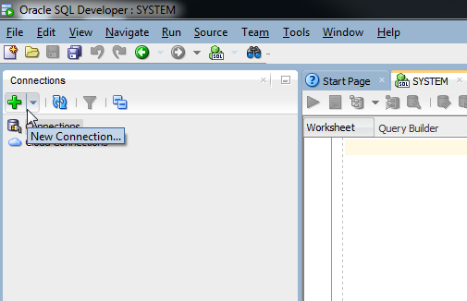](http://www.mandsconsulting.com/wp-content/uploads/2014-01-16-16_26_13-Oracle-SQL-Developer-_-SYSTEM.png)

Step 2

[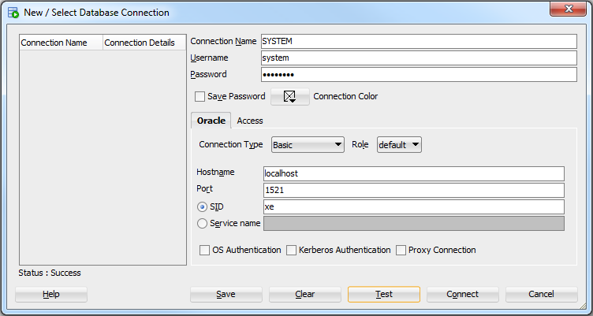](http://www.mandsconsulting.com/wp-content/uploads/2014-01-16-16_27_15-Oracle-SQL-Developer.png)Once Step 3

[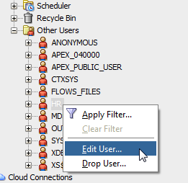](http://www.mandsconsulting.com/wp-content/uploads/2014-01-16-16_30_17-Oracle-SQL-Developer.png)

Step 4

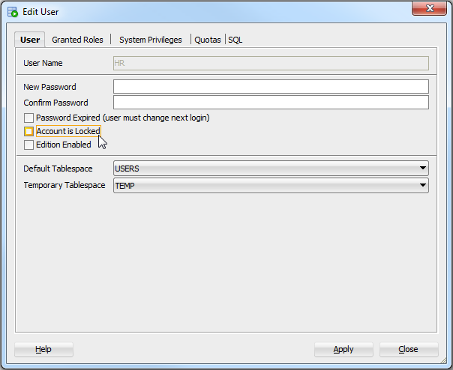After

**Пример 2. Как создать нового пользователя-схему?**

1. Run the following script in in the SQL Worksheet feature of Oracle SQL Developer (**Tools** -> **SQL Worksheet** and press F5 to execute the script) to create the new HR_COPY schema. Replace the password, USERS, and TEMP with the preferred password and tablespaces for objects and temporary space.

CREATE USER HR_COPY IDENTIFIED BY

password

DEFAULT TABLESPACE USERS TEMPORARY TABLESPACE TEMP;

GRANT CONNECT, RESOURCE to HR_COPY;

 The “user HR_COPY created” report on the **Script Output** tab indicates that the CREATE USER statement was successful.

2. To create a new schema, type the following command in the **sys** worksheet and click http://www.oracle.com/webfolder/technetwork/tutorials/obe/db/sqldev/r31/DatabaseCopy/images/RunScript.gif(RunScript)

create user hr_copy identified by hr;   
grant connect, resource, create session, unlimited tablespace to hr_copy;

**Пример 3. Изменение прав доступа пользователю**

|  |  |
| --- | --- |
| Учебный пользователь | Системный пользователь |
| -- USER SQL  ALTER USER "HR"  DEFAULT TABLESPACE "USERS"  TEMPORARY TABLESPACE "TEMP"  ACCOUNT UNLOCK  ENABLE EDITIONS ;  -- QUOTAS  ALTER USER "HR" QUOTA UNLIMITED ON USERS;  -- ROLES  ALTER USER "HR" DEFAULT ROLE "CONNECT","RESOURCE"; | -- USER SQL  ALTER USER "SYSTEM"  DEFAULT TABLESPACE "SYSTEM"  TEMPORARY TABLESPACE "TEMP"  ACCOUNT UNLOCK ;  -- QUOTAS  -- ROLES  ALTER USER "SYSTEM" DEFAULT ROLE "DBA","AQ_ADMINISTRATOR_ROLE";  -- SYSTEM PRIVILEGES |

Права на создание и загрузку дампов, права на создание материализованных представлений и триггеров

CREATE USER HR_COPY IDENTIFIED BY

hr

DEFAULT TABLESPACE USERS TEMPORARY TABLESPACE TEMP;

GRANT CONNECT, RESOURCE, imp_full_database,EXP_FULL_DATABASE to HR_COPY;

**Пример 4. Перенос данных из схемы в схему из под системного пользователя при помощи скрипта-команды**

<http://www.javaroots.com/2013/10/expdp-impdp-remote-oracle-db-example.html>

Step 1

#Login in sqlplus

sqlplus / as sysdba

Then create a public connection link for the remote database .

#Create a connection link for the database which you want to export

create database link remotelink connect to targetdbuser identified by targetdbpassword using 'hostname:port/sid'

#check connection

select * from dual@remotelink

Now create a local directory on your file system , and map it to your local oracle db like this :

# create a local directory where the dump file will be stored and map it to your database dir by creating

create directory **mydumpdir** as **'D:/MyData'**;

# give permission to local user by whom we will be running expdp

GRANT read, write ON DIRECTORY **mydumpdir** TO **HR_COPY**;

# check if the dir is created

select directory_name, directory_path from dba_directories ;

You might get following error , if you do not grant read write access of directory to the user .

ORA-39002: invalid operation

ORA-39070: Unable to open the log file.

ORA-39087: directory name mydumpdir is invalid

Now run the expdp command with specifying the directory , network link and other parameters . We are exporting a particular schema here .

Внимание в SQL Command Line нужно на приглашение SQL> поставить $ (знак доллар) чтобы перейти к возможности команд оракла-айпи

expdp userid=system/123@//localhost:1521/XE dumpfile=testdump.dmp logfile=testdump.log SCHEMAS=**HR** directory=**mydumpdir**

Шаблон-схемаы команд:

expdp fromUser/fromPword schemas=sourceSchema directory=DUMPDIR dumpfile=dump.dmp logfile=explog.txt

impdp toUser/toPword directory=DUMPDIR dumpfile=dump.dmp logfile=implog.txt remap_schema=fromUser:toUser

**Пример 5 - 6. Создание (выгрузка) дампа данных при помощи скрипта-команды для пользователя и Импорт данных в схему пользователя из дампа данных при помощи скрипта-команды для заданного пользователя**

Выгружаем - экспортируем

expdp HR/hr schemas=HR directory=MYDUMPDIR dumpfile=hrdump.dmp logfile=exphrlog.txt

Затем загружаем-импортируем под нужным пользователем

impdp HR_COPY/hr directory=mydumpdir dumpfile=hrdump.dmp logfile=imphrlog.txt remap_schema=HR:HR_COPY

или только нужные таблицы

impdp HR_COPY/hr directory=mydumpdir dumpfile=hrdump.dmp logfile=imphrlog.txt TABLES=(HR.DEPARTMENTS,HR.EMPLOYEES) remap_schema=HR:HR_COPY

**Пример 7. Импорт данных из-под системного пользователя для заданного**

imp userid=system/123@//localhost:1521/XE fromuser=HR touser=HR_COPY tables=(DEPARTMENTS,EMPLOYEES) rows=y file= **D:/MyData**/hrdump.dmp commit=Y grants=N statistics=NONE ignore=Y log= **D:/MyData**/hrdump.log

или

imp userid=system/123@//localhost:1521/XE fromuser=HR touser=HR_COPY tables=(DEPARTMENTS,EMPLOYEES) rows=y directory=mydumpdir dumpfile=hrdump.dmp commit=Y grants=N statistics=NONE ignore=Y logfile=imphrlog.txt remap_schema=HR:HR_COPY